Y5/6 Cycle A
English
Y5/6 Writing
Au1 | Au2 | Sp1 | Sp2 | Su1 | Su2
Crime and Punishment | Power vs. Principles | Affirmation and Equality | Legends, Folklore and Fairytales | Lessons from History | Solving Mysteries
The Three Little Pigs Project  The Guardian  The Promise  Nicola Davies | Rain Player  David Wisniewski  The Tempest  William Shakespeare | The Lost Thing  Shaun Tan  Freedom Bird  Jerdine Nolan | The Sleeper and the Spindle  Neil Gaiman and Chris Riddell  Grimm Tales for Young and Old  Phillip Pullman | A Beautiful Lie  Irfan Master  Alte Zachen  Ziggy Hanaor | High Rise Mystery  Sharna Jackson  Curiosity  Markus Motum

Y5/6 Reading
Au1 | Au2 | Sp1 | Sp2 | Su1 | Su2
Crime and Punishment | Power vs. Principles | Affirmation and Equality | Legends, Folklore and Fairytales | Lessons from History | Solving Mysteries
The Good Thieves  Katherine Rundell  Cosmic  Frank Cottrell Boyce | The Explorer  Katherine Rundell  Who let the Gods Out  Maz Evans | Me, My Dad and the End of the Rainbow  Benjamin Dean  Black and British: A Short, Essential History  David Olusoga | When the stars Come Out  Nicola Edwards  Sir Garwain and the Green Knight  Michael Morpurgo | After the War: From Auschwitz to Ambleside  Tom Palmer  Poems from the Second World War  Gaby Morgan | Overheard in a Tower Block  Joseph Coelho  The Secret of Haven Point  Lisette Auton

Y5/6 Spelling
Au1 | Au2 | Sp1 | Sp2 | Su1 | Su2
Crime and Punishment | Power vs. Principles | Affirmation and Equality | Legends, Folklore and Fairytales | Lessons from History | Solving Mysteries
The Good Thieves  Katherine Rundell  Cosmic  Frank Cottrell Boyce | The Explorer  Katherine Rundell  Who let the Gods Out  Maz Evans | Me, My Dad and the End of the Rainbow  Benjamin Dean  Black and British: A Short, Essential History  David Olusoga | When the stars Come Out  Nicola Edwards  Sir Garwain and the Green Knight  Michael Morpurgo | After the War: From Auschwitz to Ambleside  Tom Palmer  Poems from the Second World War  Gaby Morgan | Overheard in a Tower Block  Joseph Coelho  The Secret of Haven Point  Lisette Auton

Maths
Y5 Maths
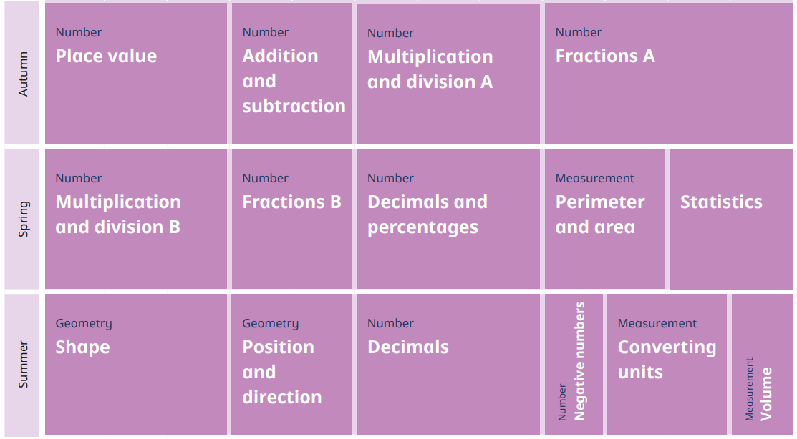

Y6 Maths
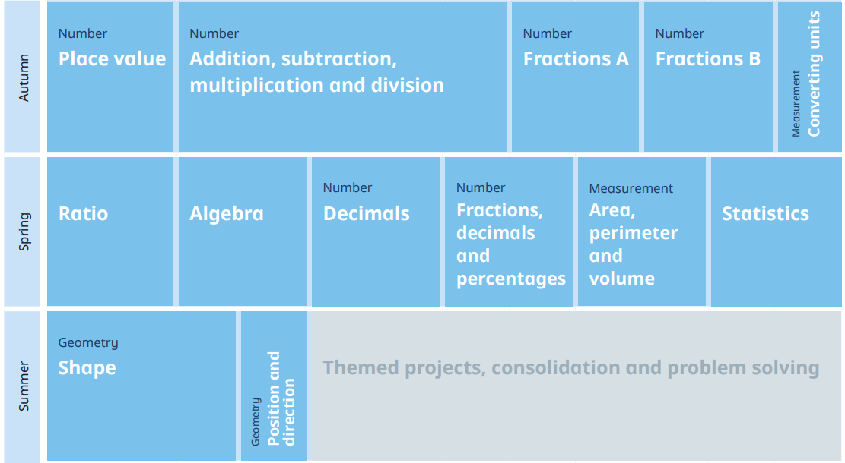

Science
Y5/6 Science
Au1 | Au2 | Sp1 | Sp2 | Su1 | Su2
Mixtures and Separation | Properties and Changes | Earth and Space | Circulation and Health | Light and Reflection | Making Connections

History
Y5/6 History
Au1 | Au2 | Sp1 | Sp2 | Su1 | Su2
Were the Vikings Traders or Something Else? |  | What was Life Like in Tudor England? |  | What Impact did WWII Have on Britain?

Geography
Y5/6 Geography
Au1 | Au2 | Sp1 | Sp2 | Su1 | Su2
 | Why Does Population Change? |  | Why do Oceans Matter? |  | Can I Carry Out an Independent Fieldwork Enquiry?

ICT
Y5/6 ICT
Au1 | Au2 | Sp1 | Sp2 | Su1 | Su2
Computing Systems and Networks | Computing Systems and Networks | Creating Media | Creating Media | Programming A | Programming B
Systems and Searching | Communication and Collaboration | Video Production | Webpage Creation | Selection in Physical Computing | Variables in Games

RE
Y5/6 RE
Au1 | Au2 | Sp1 | Sp2 | Su1 | Su2
Prayer and Worship | Christmas | Hindu Beliefs | Easter | Beliefs and Moral Values | Beliefs and Practices
Hinduism | Christianity | Hinduism | Christianity | Hinduism | Christianity
What is the best way for a Hindu to show commitment to God? | Is the Christmas story true? | How can Brahman be everywhere at once? | How significant is it for Christians to believe God intended Jesus to die? | Do beliefs in karma, Samsara and Moksha help Hindus lead good lives? | What is the best wat for a Christian to show commitment to God?

PSHE
Y5/6 PSHE
Au1 | Au2 | Sp1 | Sp2 | Su1 | Su2
Feelings and Emotions | Being Responsible | Keeping and Staying Safe | The Working World | Keeping and Staying Healthy | Growing and Changes
Making friends online | Looking out for others | Peer pressure  (Y5 First aid) | Enterprise | Inclusion and acceptance | Puberty and conception (Y6 only)

Art
Y5/6 Art
Au1 | Au2 | Sp1 | Sp2 | Su1 | Su2
Drawing and Sketchbooks |  | Surface and Colour |  | Working in Three Dimensions
2D Drawing to 3D Making |  | Activism  or  Exploring Identity |  | Brave Colour  or  Take a Seat  or  Shadow Puppets

Design Technology
Y5/6 DT
Au1 | Au2 | Sp1 | Sp2 | Su1 | Su2
 | Building Bridges |  | Chinese Inventions |  | Fashion and Textiles

